**For discussion on shielding calculations, July 7th, 2016**

It is *assumed* the lab utilizing X-ray techniques will be located in the SE-corner of Etcheverry 1140. EHS approval is requested for a system where the X-ray source position within the shielded area can be moved, MC radiation exposure calculations are requested for three worst case scenarios. Sketch of 1140 and shielding is included below. The green “walls” represent walls composed of the (36”)3 keyed heavy Barite concrete shielding blocks stacked 4 tall. EHS has approved simplifying the geometry (*i.e.* utilizing only rectangular blocks). *Note: Dimensions of Etch1140 have not been measured precisely. They may need to be checked by SM or others before carrying out the calculations.*

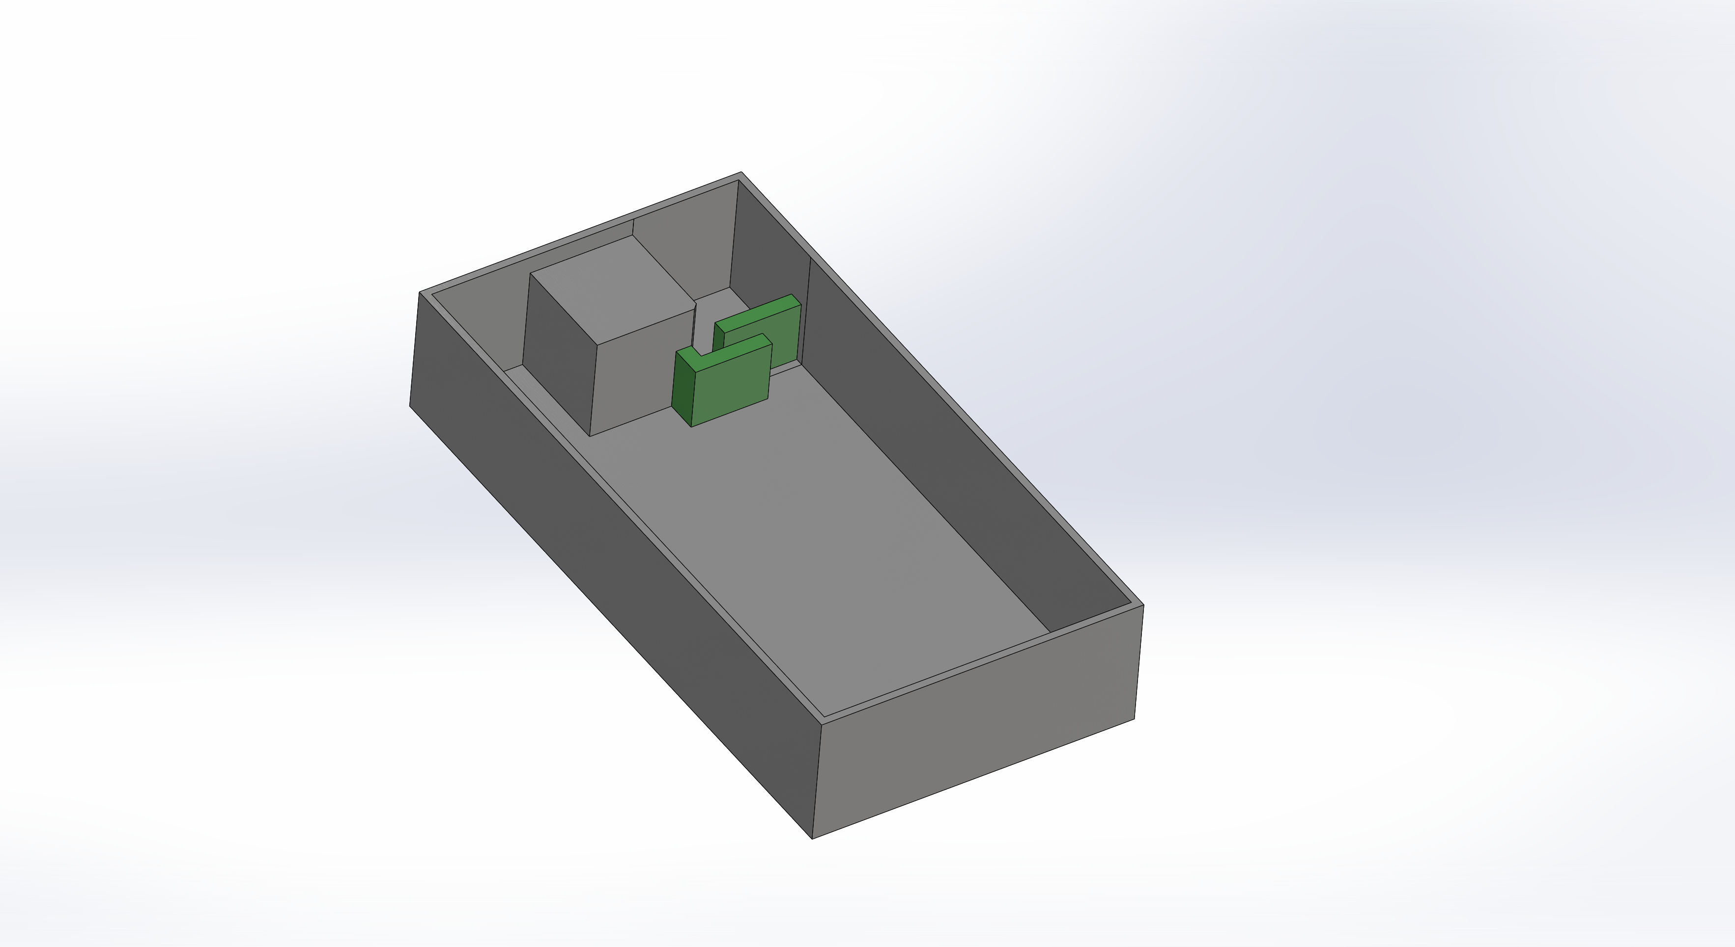

The requested output is 3D contours of

* 2.0 mR/hr zone in Etch1140 (and class room above, if dose there >0.2 mR/hr)
* 0.2 mR/hr zone in Etch1140 (and class room above, if dose there >0.2 mR/hr)
* *Optional and not required by EHS, if generating this does not require significant extra effort: contours of 0.01, 0.05, 0.1, 0.2, 1, 2, 5, 10 mR/hr zones as a multi-color (heat) map*

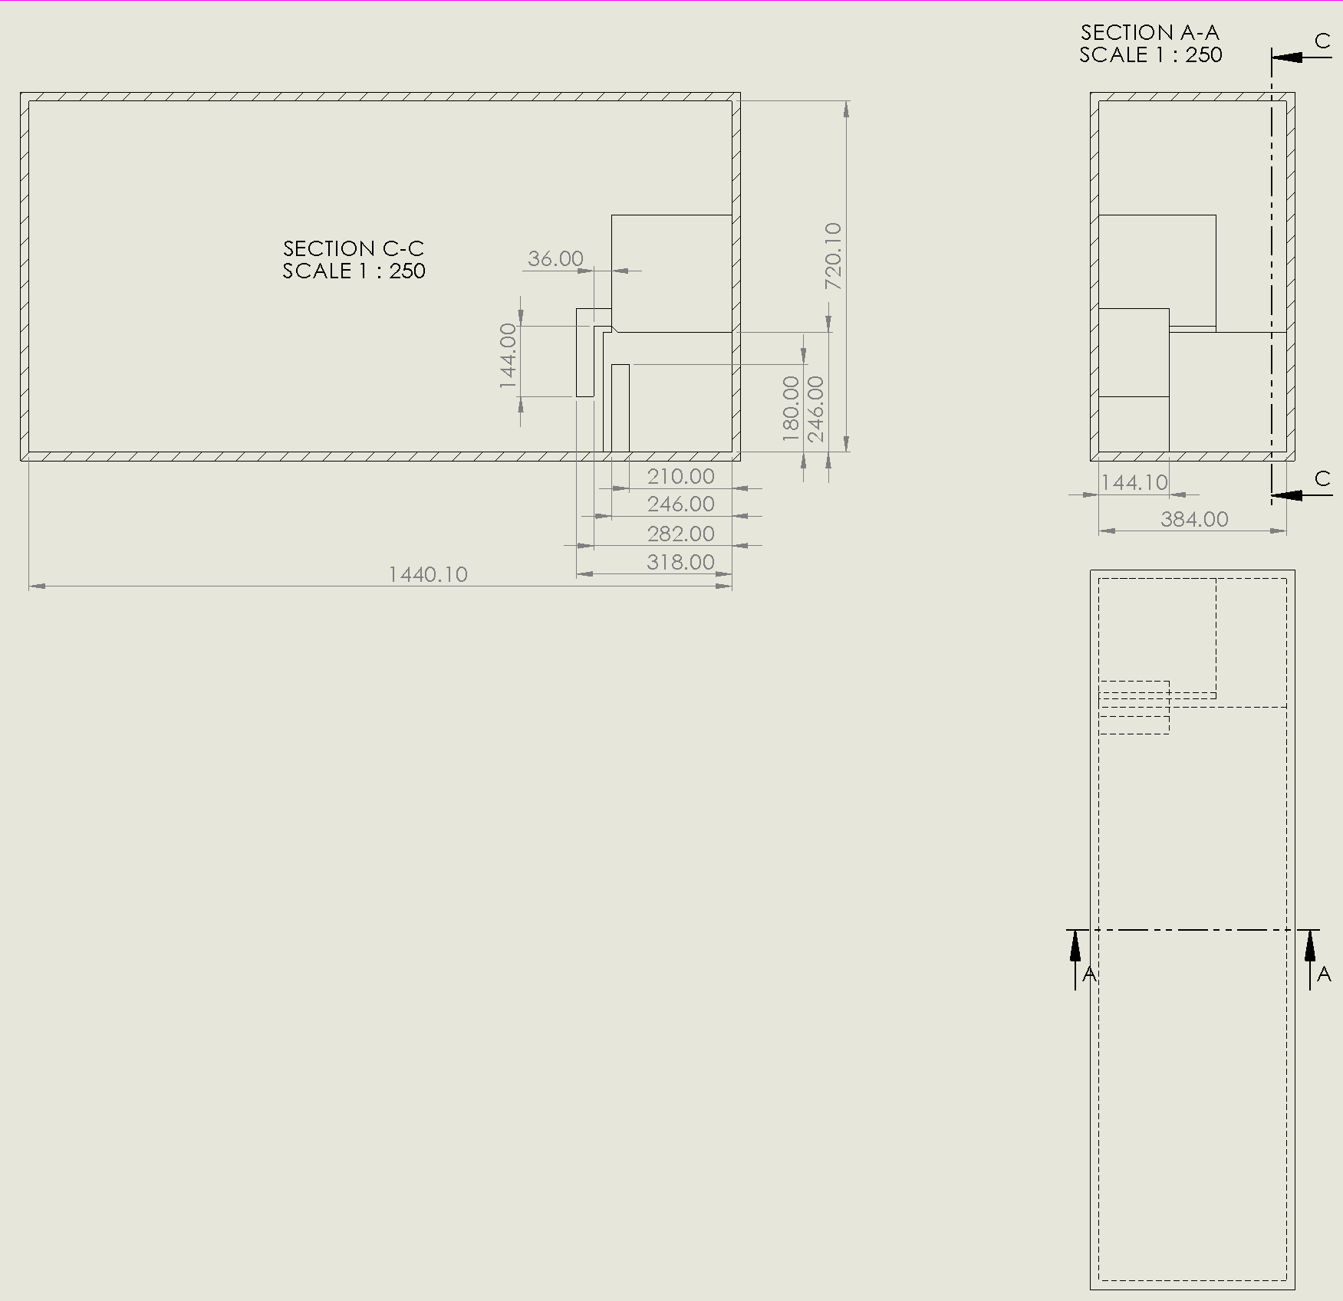

Scenario 1: Tube pointed straight up, operated at 225 kV & 320 W

* Exposure to people in class room above (trough 18”+ of Barite)?
* Exposure to people in 1140?

Assume:

* Tube located 9ft above the floor, pointing up, and 3ft from block-wall

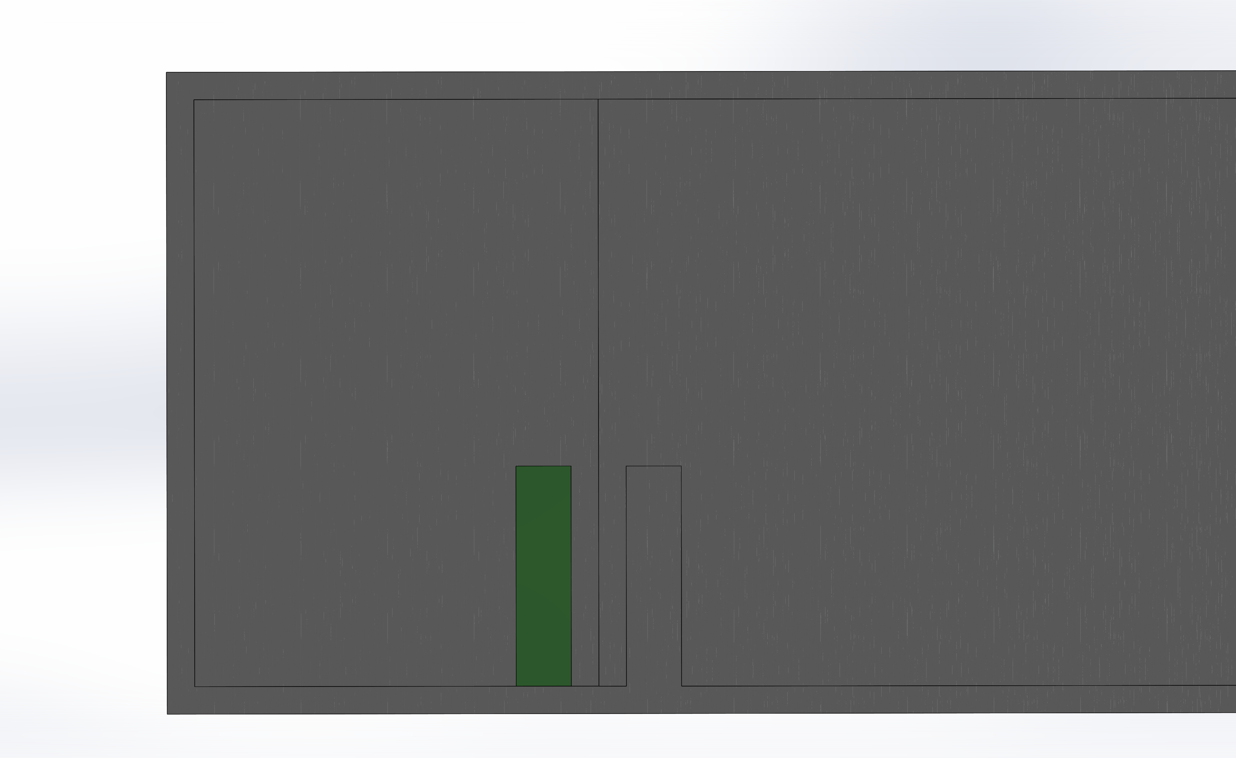

Scenario 2: Tube is pointed up at 45deg, operated at 225 kV & 320 W

* Exposure to people in class room above (trough 18”+ of Barite)?
* Exposure to people in 1140 from skyshine

Assume:

* Tube located 9ft above the floor, pointing up at 45 degrees, and 3ft from block-wall



Scenario 3: Tube is horizontal, operated at 225 kV & 320 W

* Exposure to people in class room above (trough 18”+ of Barite)?
* Exposure to people in 1140?

Assume:

* Tube located 6ft above the floor, pointing up, and 0ft from block-wall
* Only one wall between personnel (*i.e*. tube 2ft from neutron source wall)

